**PIZZA SALES SQL QUERIES**

**A. KPI’s**

**1. Total Revenue:**

**SELECT SUM(total_price) AS Total_Revenue FROM pizza_sales;**

**2. Average Order Value**

**SELECT (SUM(total_price) / COUNT(DISTINCT order_id)) AS Avg_order_Value FROM pizza_sales;**

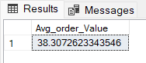

**3. Total Pizzas Sold**

**SELECT SUM(quantity) AS Total_pizza_sold FROM pizza_sales;**

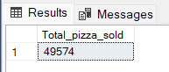

**4. Total Orders**

**SELECT COUNT(DISTINCT order_id) AS Total_Orders FROM pizza_sales;**

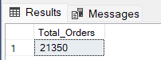

**5. Average Pizzas Per Order**

**SELECT CAST(CAST(SUM(quantity) AS DECIMAL(10,2)) /**

**CAST(COUNT(DISTINCT order_id) AS DECIMAL(10,2)) AS DECIMAL(10,2))**

**AS Avg_Pizzas_per_order**

**FROM pizza_sales;**

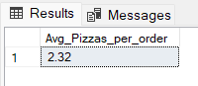

**B. Daily Trend for Total Orders  
SELECT TO_CHAR(order_date,'Day') AS order_day,COUNT(DISTINCT order_id) AS total_orders**

**FROM pizza_sales**

**GROUP BY TO_CHAR(order_date,'Day');**

***Output:***

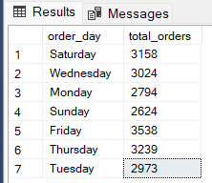

**C. Monthly Trend for Orders**

**SELECT TO_CHAR(order_date,'Month') AS Month_Name,COUNT(DISTINCT order_id) AS Total_Orders**

**FROM pizza_sales**

**GROUP BY TO_CHAR(order_date,'Month');**

***Output:***

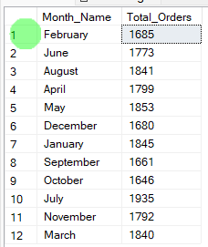

**D. % of Sales by Pizza Category**

**SELECT pizza_category,SUM(total_price) AS total_revenue, SUM(total_price) *100 / (Select SUM(total_price) FROM pizza_sales) AS PCT**

**FROM pizza_sales**

**GROUP BY pizza_category;**

***Output***

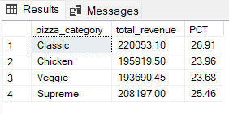

**E. % of Sales by Pizza Size**

**SELECT pizza_size,SUM(total_price) AS total_sales, CAST((SUM(total_price) * 100) / (SELECT SUM(total_price) FROM pizza_sales) AS DECIMAL(10,2)) AS PCT**

**FROM pizza_sales**

**GROUP BY pizza_size**

**ORDER BY PCT DESC;**

***Output***

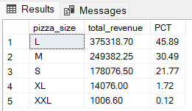

**F. Total Pizzas Sold by Pizza Category**

**SELECT pizza_category, SUM(quantity) as Total_Quantity_Sold**

**FROM pizza_sales**

**GROUP BY pizza_category**

**ORDER BY Total_Quantity_Sold Desc;**

***Output***

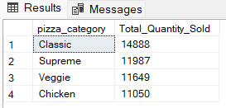

**G. Top 5 Pizzas by Revenue**

**SELECT pizza_name,SUM(total_price) AS total_revenue**

**FROM pizza_sales**

**GROUP BY pizza_name**

**ORDER BY total_revenue DESC LIMIT 5;**

***Output***

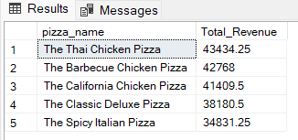

**H. Bottom 5 Pizzas by Revenue**

**SELECT pizza_name,SUM(total_price) AS total_revenue**

**FROM pizza_sales**

**GROUP BY pizza_name**

**ORDER BY total_revenue ASC LIMIT 5;**

***Output***

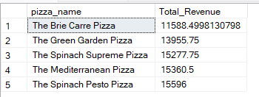

**I. Top 5 Pizzas by Quantity**

**SELECT pizza_name,SUM(quantity) AS Total_Quantity**

**FROM pizza_sales**

**GROUP BY pizza_name**

**ORDER BY Total_Quantity DESC LIMIT 5;**

***Output***

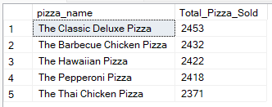

**J. Bottom 5 Pizzas by Quantity**

**SELECT pizza_name,SUM(quantity) AS Total_Quantity**

**FROM pizza_sales**

**GROUP BY pizza_name**

**ORDER BY Total_Quantity ASC LIMIT 5;**

***Output***

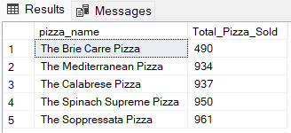

**K. Top 5 Pizzas by Total Orders**

**SELECT pizza_name,COUNT(DISTINCT order_id) AS Total_Orders**

**FROM pizza_sales**

**GROUP BY pizza_name**

**ORDER BY Total_Orders DESC LIMIT 5;**

***Output***

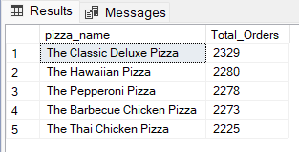

**L. Bottom 5 Pizzas by Total Orders**

**SELECT pizza_name,SUM(quantity) AS Total_Quantity**

**FROM pizza_sales**

**GROUP BY pizza_name**

**ORDER BY Total_Quantity ASC LIMIT 5;**

***Output***

